13 ATTRIBUTES OF GOD'S MERCY. Exodus 34:6,7
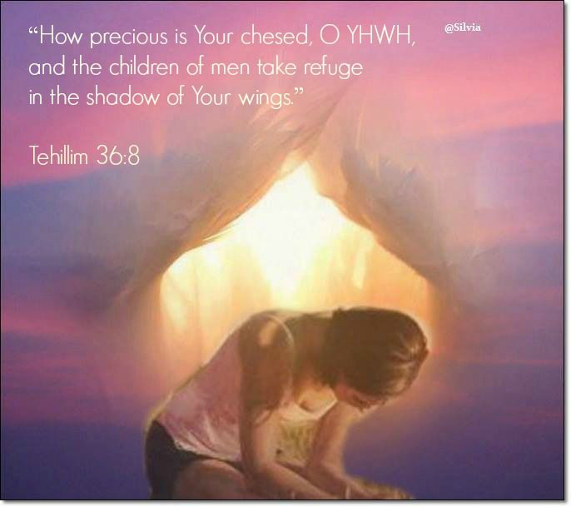
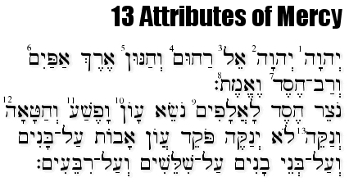
SHELOSH ESRET MIDDOT are in the following 2 verses from Exodus. They show us the very nature of God: Exodus 34:6,7 And the Lord passed by before him and proclaimed, " the Lord, the Lord God, merciful and gracious patient and abundant in loving-kindness and truth. Keeping loving-kindness for thousands, forgiving iniquity, transgression and sin, and who will by no means clear the guilty, visiting the iniquity of the fathers upon the children and upon the children's children, to the third and to the fourth generations.

(their sins are visited in two ways: the repentant are forgiven, not the unrepentant the result of the sin causes pain even when sin has been forgiven.)
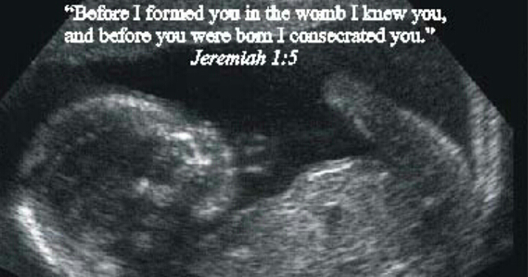

1 The Lord I the Lord am the MERCIFUL source of life. This name speaks of mercy, repeated here because it refers to 2 different kinds of mercy. The first is that God's mercy flows before someone sins, even though he knows how that one will sin in the future.
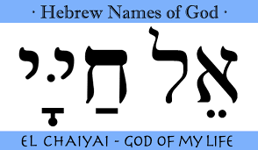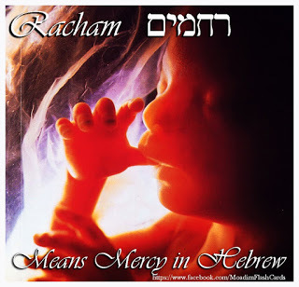
2 The Lord. ADONAI The repetition of God's name indicates that He is merciful to a person after he has sinned and shown repentance. the second use of his name is for his mercy in forgiving the sinner after repentance. This four letter name of God is the only word for God that is used in the passages telling of the offerings for forgiveness of sin, showing His mercy.
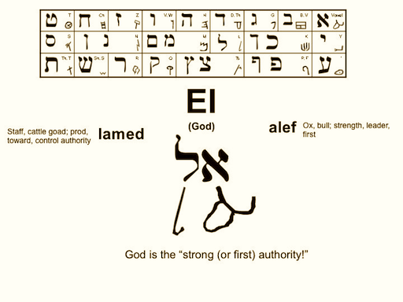
3 El, God. God the MIGHTY He is the RIGHTFUL JUDGE. This word symbolizes power, bringing an even greater level of mercy than the previous name.
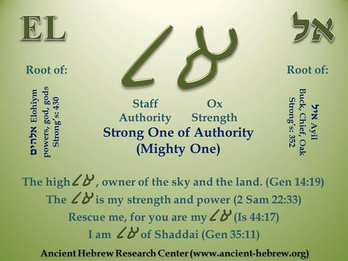

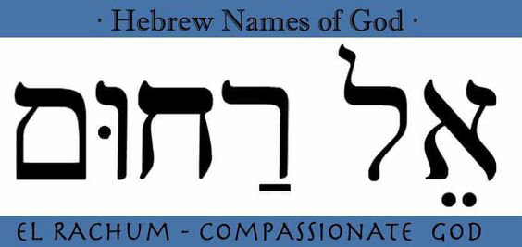
4 Rakhoom, compassionate. RACUM - God the COMPASSIONATE. merciful to the poor and downtrodden. God reduces the punishment of the guilty. Word denotes pity, compassion,love and mercy. Deut 4:31; Jer31:20
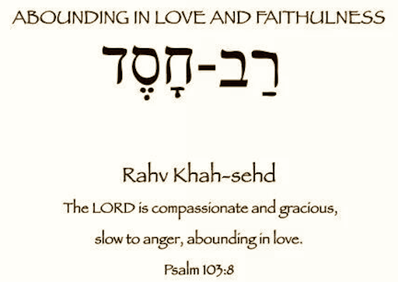
5 Vekhanoon, and gracious. VE'CHANUN -God is GRACIOUS and GENEROUS even to the undeserving. He is gracious even to the undeserving. This word denotes grace, beauty, charm and loveliness. Zech12:10
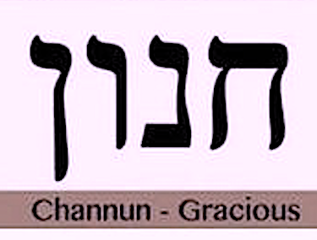
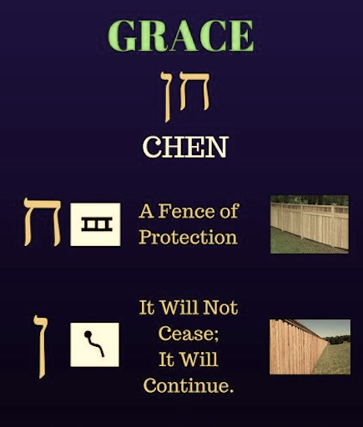
6 Erech Apayim, slow to anger, EREKH APAYIM - God is SLOW T0 ANGER and PATIENT in waiting for our repentance. With both the righteous and the wicked, God is patient. Instead of punishing sinners immediately, He gives them time to reflect improve and repent. Neh. 9:17
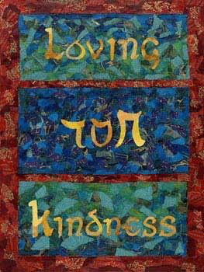
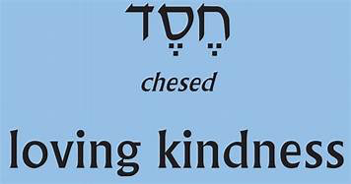
7 VE'RAV CHESED God is abundant in KINDNESS to both righteous and wicked. VeRav Khesed, and abundant in loving-kindness. His love surpasses human understanding, even loving His enemies. Num 14:18 19 Mic 9:18
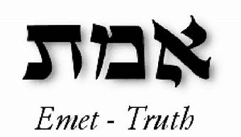
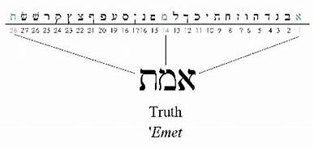
8 VE'EMET - God is TRUTHFUL and FAITHFUL in carrying out promises. VeEmet, and truth. The adjective abundant (above) also modifies truth. Loving-kindness precedes truth because the truth must always be spoken and it must always be spoken in love. God never reneges on his word towards those who serve him. Ps 31:5; Jn.4:6
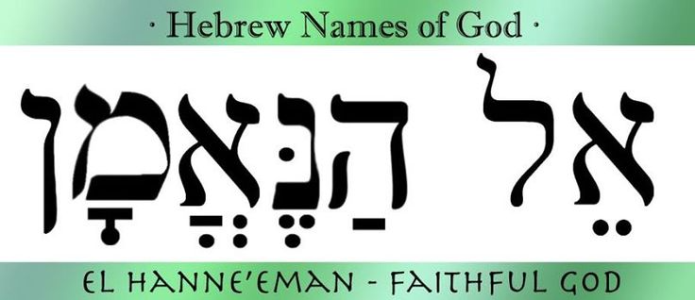
9 NOTZER CHESED LA’ALAFIM God extends KINDNESS for 1000 generations. {ZECHUT AVOTJ taking into account the merit of our worthy ancestors. Notser Khesed Lalpim, preserver of loving-kindness for thousands of generations. The kindness in this context refers to the good deeds of people, which God regards as if they had done Him kindnesses. Matt 25:35-40 Ps16:10, 59:17; Isa 58:1O God forgives three categories of sin and each forgiveness is reckoned as a separate quality.
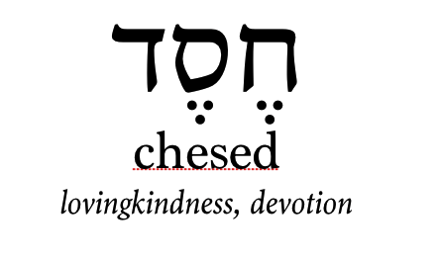
10 NOSEI AVON - God forgives iniquity-defined in the tradition as wrongful deeds committed with premeditation. Avon, iniquity, that is an intentional sin, which God forgives if the sinner repents lSam 25;28

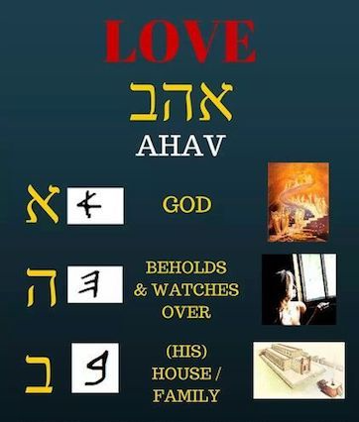
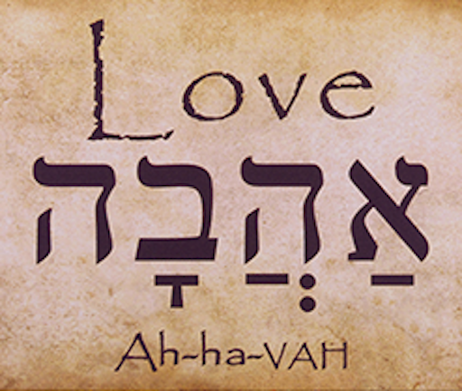
11 VAFESHA - God forglves transgression- defined as wrongful deeds committed in a rebellious spirit. VaFesha, and willful sin, that is a sin that is committed with the intention of angering God. Even so serious a transgression will be forgiven, with repentance. Num 15:30 Isa 43:25
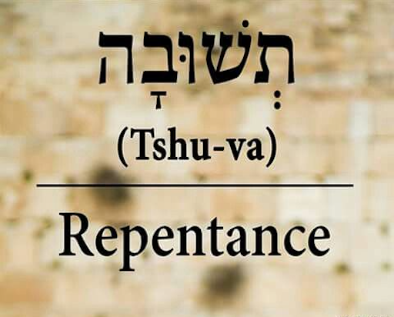

12 VE'CHATA'AH God forgives sin- those wrongful deeds that were inadvertent. VeKhata-ah, and error, a sin committed out of apathy or carelessness. Is 5:18
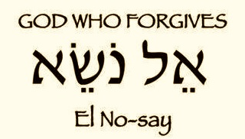

13 VE'NAKEH God will cancel all punishment for those who are truly repentant. VeNakeh, and who cleanses. When someone repents, God cleanses his sin, so that the effect of the Sin vanishes and the penalty of death is not required of that individual. However if one does not repent He does not cleanse. God cleanses fully those who repent out of love. Those who repent only out of fear of retribution receive only partial cleansing.
The first word, who cleanses, is the final quality of mercy. This translation follows the plain meaning which teaches that God does not whitewash sin. For to do so would remove the distinction between good and evil and would encourage evildoers to feel secure that they can act boldly, for there will be no punishment.
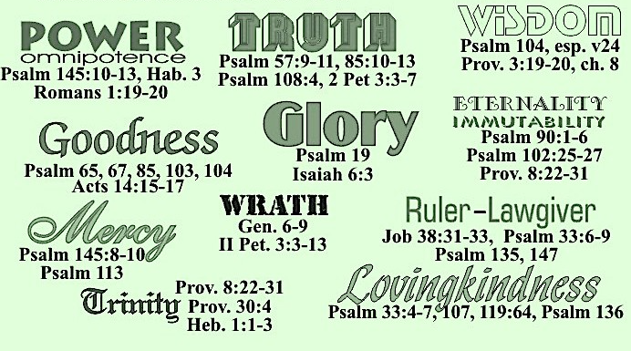
Adonai (1) Adonai (2) El (3) Rachum (4) Ve'chanun (5) erekh apayim (6) The Lord (1) the Lord (2) a God (3) merciful (4) and gracious (5) and slow to anger (6)
Ve'rav-chesed (7) ve'emet(8) nosei
abounding in steadfast love (7) and faithfulness (8)
notzer chesed la'alafim (9J (ZECHUT AVOT)
keeping steadfast love for thousands (9)taking into account the merit of our worthy ancestors.)
Nosei avon [l0J vapesha (11) ve'chata'ah (12)
forgiving iniquity (10) and transgression (11) and sin (12)
ve'nakeh[13J
cancel all punishment (13)
lo yenakeh poked avon avot al-banim ve'al benei vanim al-shileshim ve'al-ribeim
who will by no means clear the guilty (13J visiting the iniquity of the fathers to the children and their children's children to the third and fourth generation.
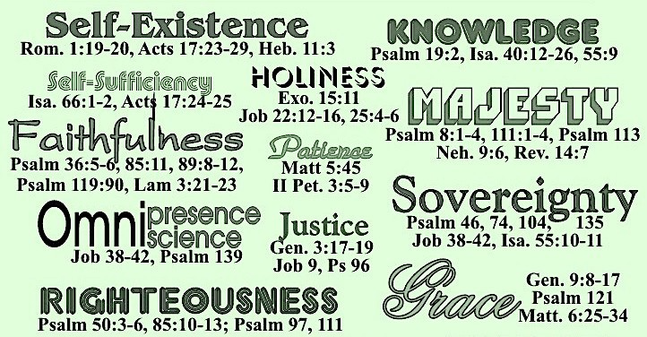
6. Va•ya•a•vor Adonai al-pa•nav va•yik•ra Adonai Adonai El ra•choom ve•cha•noon e•rech apa•yim ve•rav-che•sed ve•emet.
6. And the Lord passed by before him, and proclaimed, The Lord, The Lord God, merciful and gracious, long suffering, and abundant in goodness and truth,
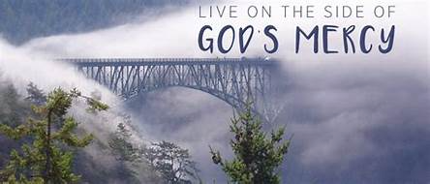

7. No•tzer che•sed la•ala•fim no•se avon va•fe•sha ve•cha•ta•ah ve•na•ke lo ye•na•ke po•ked avon avot al-ba•nim ve•al-b`nei va•nim al-shi•le•shim ve•al- ri•be•eem
7. Keeping mercy for thousands, forgiving iniquity and transgression and sin, and that will by no means clear the guilty; visiting the iniquity of the fathers upon the children, and upon the children's children, to the third and to the fourth generation.
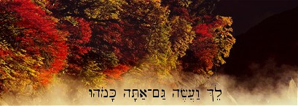
Zivchei -right sacrifices likewise

